**PIZZA SALES SQL QUERIES**

**A. Retrieve the total number of orders placed.**

**SELECT**

**COUNT(order_id) AS total_orders**

**FROM**

**orders;**

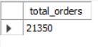

**B. Calculate the total revenue generated from pizza sales.**

**SELECT**

**ROUND(SUM(order_details.quantity * pizzas.price),**

**2) AS total_revenue**

**FROM**

**order_details**

**JOIN**

**pizzas ON pizzas.pizza_id = order_details.pizza_id;**

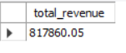

**C. Identify the highest-priced pizza.**

**SELECT**

**pizza_types.name, pizzas.price**

**FROM**

**pizza_types**

**JOIN**

**pizzas ON pizza_types.pizza_type_id = pizzas.pizza_type_id**

**ORDER BY pizzas.price DESC**

**LIMIT 1;**



**D. Identify the most common pizza size ordered.**

**SELECT**

**pizzas.size,**

**COUNT(order_details.order_details_id) AS order_count**

**FROM**

**pizzas**

**JOIN**

**order_details ON pizzas.pizza_id = order_details.pizza_id**

**GROUP BY pizzas.size**

**ORDER BY order_count DESC**

**LIMIT 1;**



**E. List the top 5 most ordered pizza types along with their quantities.**

**SELECT**

**pizza_types.name, SUM(order_details.quantity) AS quantity**

**FROM**

**pizza_types**

**JOIN**

**pizzas ON pizza_types.pizza_type_id = pizzas.pizza_type_id**

**JOIN**

**order_details ON order_details.pizza_id = pizzas.pizza_id**

**GROUP BY pizza_types.name**

**ORDER BY quantity DESC**

**LIMIT 5;**

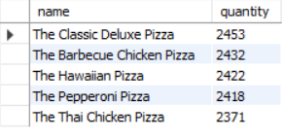

**F. Join the necessary tables to find the total quantity of each pizza category ordered.**

**SELECT**

**pizza_types.category, SUM(order_details.quantity) AS quantity**

**FROM**

**pizza_types**

**JOIN**

**pizzas ON pizza_types.pizza_type_id = pizzas.pizza_type_id**

**JOIN**

**order_details ON order_details.pizza_id = pizzas.pizza_id**

**GROUP BY pizza_types.category order by quantity desc;**

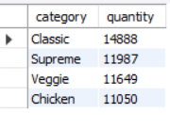

**G. Determine the distribution of orders by hour of the day.**

**SELECT**

**HOUR(order_time) AS hours, COUNT(order_id) AS order_count**

**FROM**

**orders AS order_count**

**GROUP BY HOUR(order_time)**

**ORDER BY hours;**

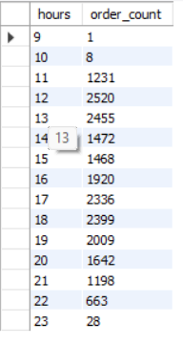

**H. Find the category-wise distribution of pizzas.**

**SELECT**

**category, COUNT(name) AS count**

**FROM**

**pizza_types**

**GROUP BY category;**

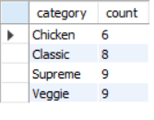

**I. Group the orders by date and calculate the average number of pizzas ordered per day.**

**SELECT**

**ROUND(AVG(quantity), 0) as avg_pizza_ordered_per_day**

**FROM**

**(SELECT**

**orders.order_date, SUM(order_details.quantity) AS quantity**

**FROM**

**orders**

**JOIN order_details ON orders.order_id = order_details.order_id**

**GROUP BY orders.order_date) AS order_quantity;**



**J. Determine the top 3 most ordered pizza types based on revenue.**

**SELECT**

**pizza_types.name,**

**SUM(order_details.quantity * pizzas.price) AS revenue**

**FROM**

**pizza_types**

**JOIN**

**pizzas ON pizzas.pizza_type_id = pizza_types.pizza_type_id**

**JOIN**

**order_details ON order_details.pizza_id = pizzas.pizza_id**

**GROUP BY pizza_types.name**

**ORDER BY revenue DESC**

**LIMIT 3;**

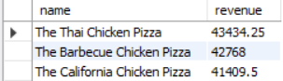

**K. Calculate the percentage contribution of each pizza type to total revenue.**

**SELECT**

**pizza_types.category,**

**ROUND(SUM(order_details.quantity * pizzas.price) / (SELECT**

**ROUND(SUM(order_details.quantity * pizzas.price),**

**2) AS total_revenue**

**FROM**

**order_details**

**JOIN**

**pizzas ON pizzas.pizza_id = order_details.pizza_id) * 100,**

**2) AS revenue**

**FROM**

**pizza_types**

**JOIN**

**pizzas ON pizza_types.pizza_type_id = pizzas.pizza_type_id**

**JOIN**

**order_details ON order_details.pizza_id = pizzas.pizza_id**

**GROUP BY pizza_types.category**

**ORDER BY revenue DESC;**

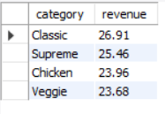

**L. Analyse the cumulative revenue generated over time.**

**select order_date,round(revenue,2) as revenue,round(sum(revenue) over (order by order_date),2) as cumulative_revenue**

**from**

**(select orders.order_date,sum(order_details.quantity*pizzas.price) as revenue**

**from order_details join pizzas**

**on order_details.pizza_id = pizzas.pizza_id**

**join orders**

**on orders.order_id = order_details.order_id**

**group by orders.order_date) as sales;**

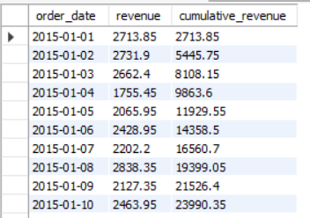

**M. Determine the top 3 most ordered pizza types based on revenue for each pizza category.**

**select name,revenue,rn from**

**(select category, name, revenue,rank() over(partition by category order by revenue desc) as rn**

**from**

**(select pizza_types.category, pizza_types.name, sum((order_details.quantity)*pizzas.price) as revenue**

**from pizza_types join pizzas**

**on pizza_types.pizza_type_id = pizzas.pizza_type_id**

**join order_details**

**on order_details.pizza_id = pizzas.pizza_id**

**group by pizza_types.category, pizza_types.name) as a) as b**

**where rn<=3;**

